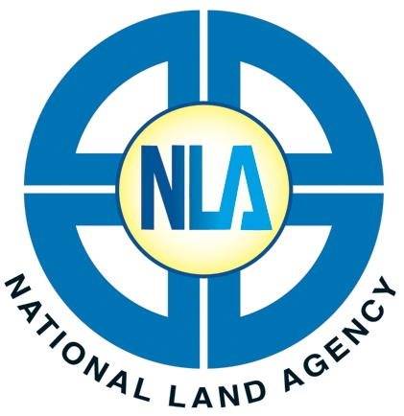
eLandjamaica Payment Form

NATIONAL LAND AGENCY

23 ½ Charles Street, Kingston, Jamaica

Tel: (876) 750-5263 / 946-5263 • Fax: (876) 948-9513
Website: www.nla.gov.jm
Queries: asknla@nla.gov

Date: ________________________ (dd/mm/yyyy)

Accountname______________________________________________________________

Company/Account Holder’s Name_________________________________________________

Address _______________________________________________________________________

Paid in by ______________________________________________________________________

Payment Amount $_______________________ Signature ____________________________

Payment Type:
Cash Managers Cheque Credit Card Debit Card

Payment Location:
Ardenne Road Hanover Street Charles Street Mandeville
Montego Bay

For Official Use Only

Receipt No. / Transaction No. ________________________

Total Paid In _____________________________________

Cashier __________________________________________

Cashier’s Signature_________________________________ Date ________________

