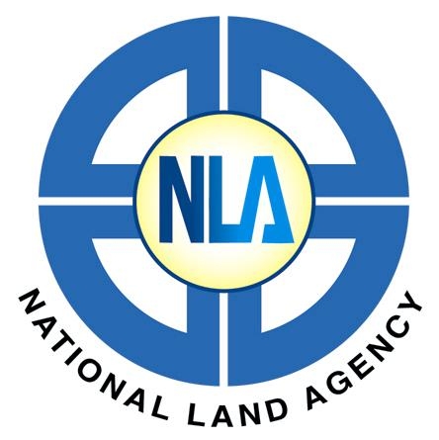

NATIONAL LAND AGENCY

8 Ardenne Road, Kingston 10, Jamaica

Tel: (876) 750-5263/946-5263 • Fax: (876) 978-0021
Website: www.nla.gov.jm

Land Registration and Conveyancing Training Course
Application Form

A) Applicant Information
Name:
Date of Birth: | Gender: □ Male □ Female | Phone:
Current address:
City: | Email Address:

B) Employment Information
Current Employer:
Employer’s Address:
Position: | E-mail:
City: | Phone: | Fax:

C) Emergency Contact
In case of Emergency please contact:
Address: |  | City:
Phone: | Phone: | Relationship:

Signature of applicant: | Date:

D) Authorization
Please invoice (Name of Company/Person):
Name of Authorizing Officer:
Title/Position:
Signature: | Date:
NB: Payments must be made by May 7, 2013

Authorization stamp or seal

E) For NLA Use Only
Coordinating Officer:
Application Received: | Date of Registration:
Status: □ Accepted □ Not Accepted
Participation Completed: | Certificate/Results Issued:

